DEPARTMENTAL ACTIVITY REPORT OF HINDI DEPARTMENT
- FACULTY EXCHANGE PROGRAMME (07/03/2024) 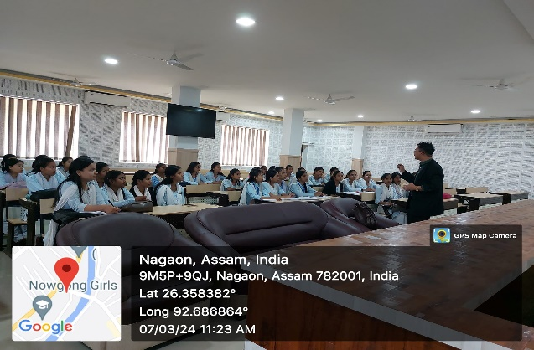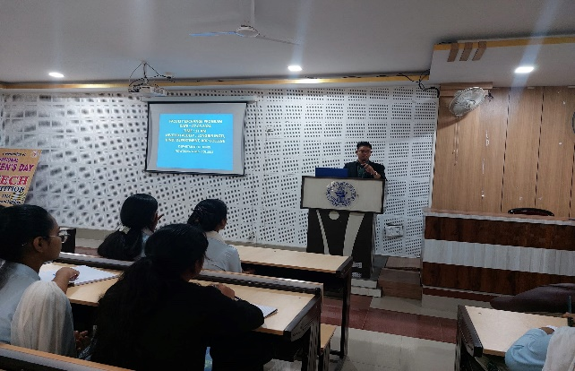
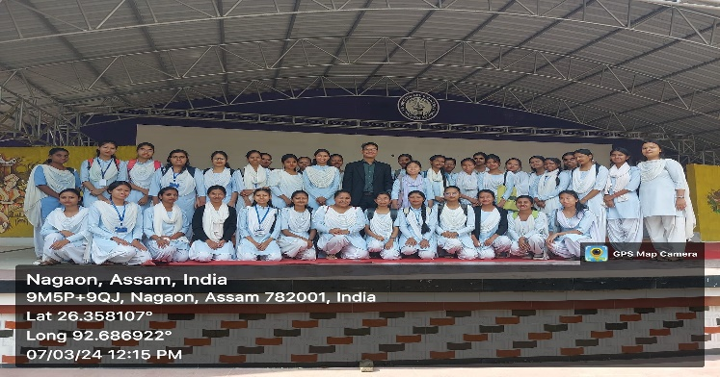
On dated 7thMarch 2024, Department of Hindi, of Nowgong Girls College have organized a Faculty Exchange programme. LongbirEngti, Assistant Professor, Dept Of Hindi, AnandaramDehkial Phukan College was in the programme and he educate our students with the topic ‘premchgand ka sahitya’. The objective of the programme was to reinforcethe knowledge of the students and to exchange new believes and ideas through the class.
- EDUCATIONAL TOUR TO AMSOI (03/03/2024)
On dated. 3rd March 2024 Department of Hindi, of Nowgong Girls College have arranged an Educational Tour to Amsoi, Ngaon, Assam. It was one day trip. Students of 6th semester, hindi department participated in this educational tour. Threeteachers have also joined inthe tour as a teacher guide. Their names are-
1. DrManikaSaikia, Dept of Hindi
2. Dr. Baby Biswakarma, Dept of Hindi
3. Prarthana Gogoi, Dept of Hindi
OBJECTIVE OF THE EDUCATIONAL TOUR:-
The purpose of this educational tour is to see the scenic beauty of Amsoi.We reached the venue at 10:00 am. We were all curious to witness the rich biodiversity of Assam. After wandering a lot in the lush landscape of the placeand witnessing Sivakunda waterfall we sat down for taking lunch around 2pm. Then we started the return journey to our homes. Really it was a pleasant experience. Besides, the visit enhanced our knowledge about this great historical place and our rich culture and tradition. Here is the few snaps of the education tour as below—
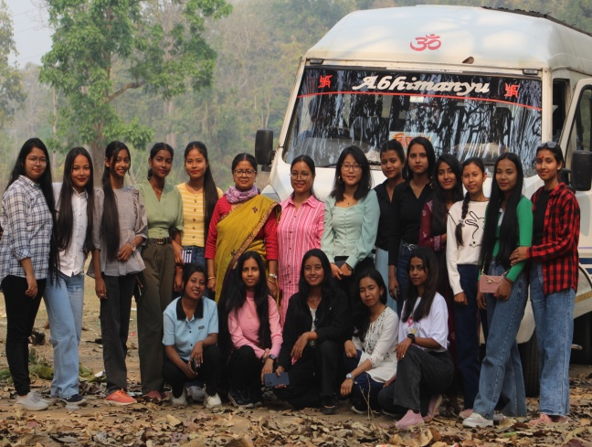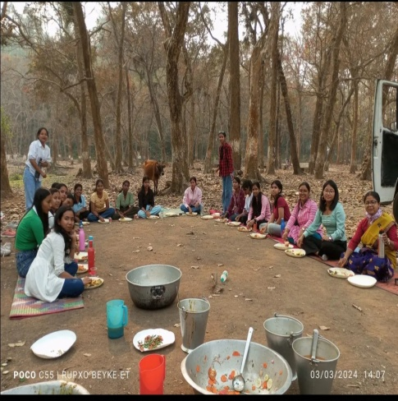
Reply
- LECTURE PROGRAMME (16/03/2024)
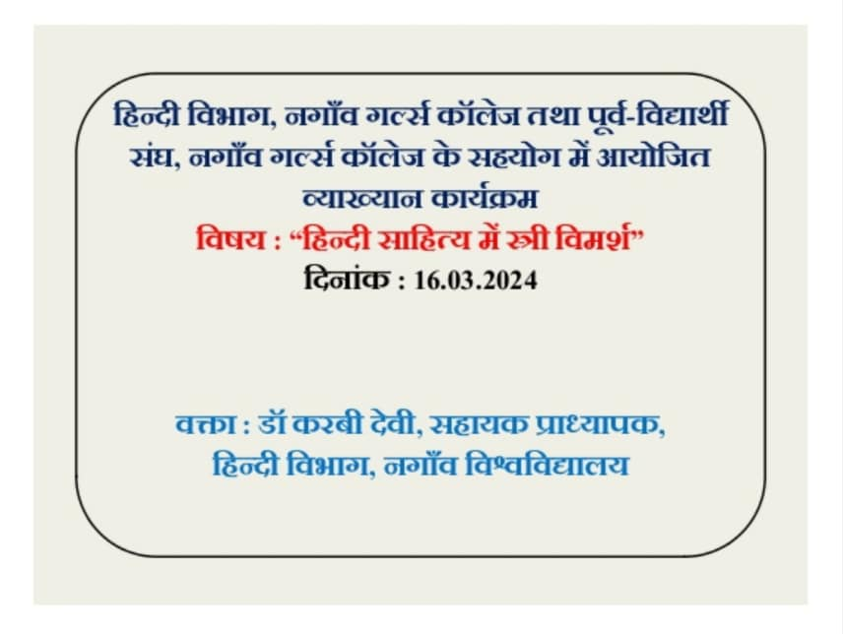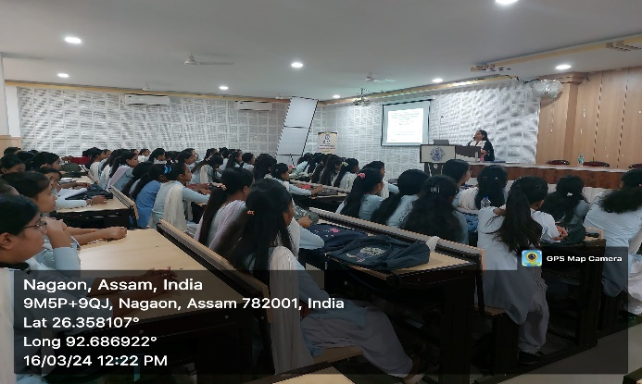

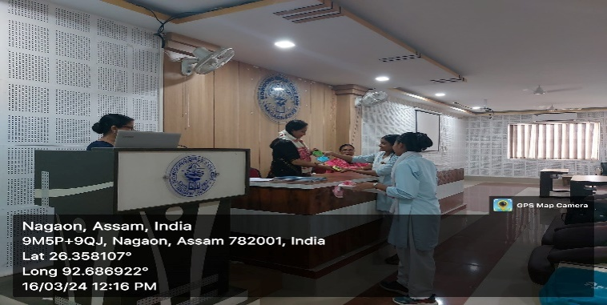
A Lecture Program Was Organized By Dept Of Hindi On 16/03/2024 on ‘Hindi sahitya meinstreevimarsh’ in presence of all the faculty members and students of the department. Karabi Devi, Assistant Professor, Nowgong College (Autonomous) was the keynote speaker of the program. She delivers her speech on ‘Feminism: its emergence, history and current scenario, with reference to the book ‘Aapka Banti’, written by Mannu Bhandari. As this book was in the syllabus of fourth semester students. And this programme was fruitful for the student of the dept.
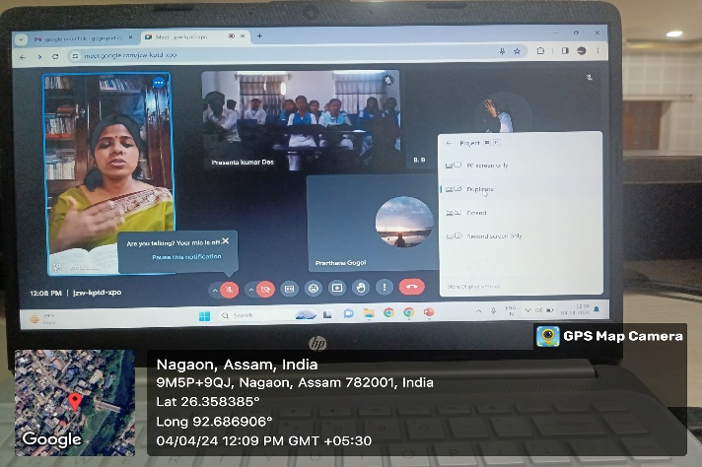
- One Day SEMINAR (04/04/2024)
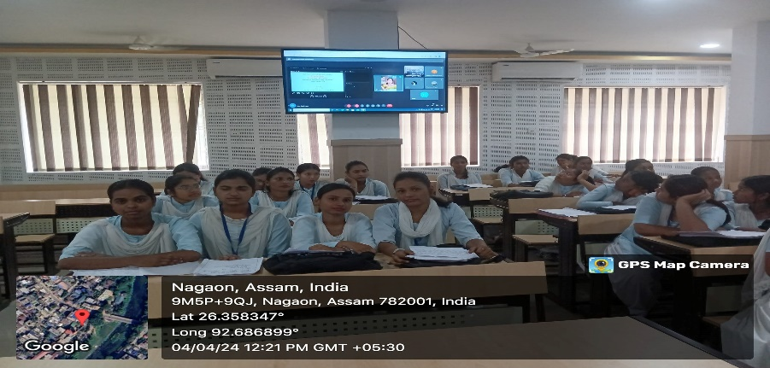
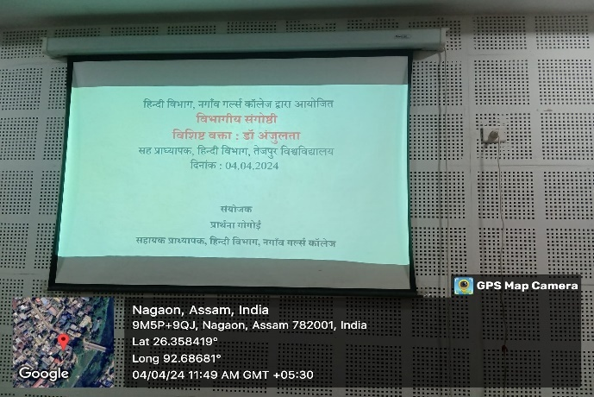
An In-House Seminar Was OrganisedBy The Dept Of Hindi On 04/04/2024 in presence of all the faculty members and students of the department. Dr. Anjulata, Assistant Professor, Dept of Hindi, Tezpur university was present in the programme through online platform. She delivers her speech on ‘ Aapka Banti’ in details and it was a fruitful programme which enhance the learning ability of the student. This programme was organised to improve the knowledge of students regarding seminar, as well as how to write a paper and present in a seminar, which will help them in higher education.

